Bus Staging

University of Houston

Energy Research Park

5000 Gulf Freeway

Houston, TX 77023

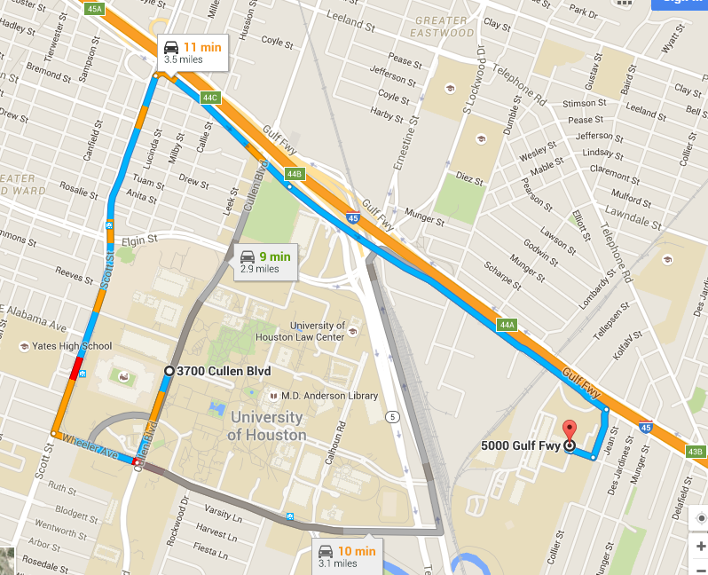

Academy Students

D/O & P/U Location

Circle Drive in front of Student Center – South

(GOLD STAR)  
4455 University Drive

Houston, TX 77004

Visitor Parking Garage

Inside of

University of Houston

Welcome Center

4400 University Drive

Houston, TX 77004

